Campus Locations:

Frassati Hall
275 N 3rd St
Lander, WY 82520

Baldwin Building
306 Main St
Lander, WY 82520

Augur Building
427 Main St
Lander, WY 82520

Holy Rosary Parish/Upper Campus
163 Leedy Dr
Lander, WY 82520

St. Gianna Molla & St. Josemaria Escriva Residence Halls
260 Grandview Dr
Lander, WY 82520

St. Benedict Residence & St. Scholastica Residence Halls
216 Valley View Dr
Lander, WY 82520

The Crest of Wyoming Catholic College captures the mission of the college. The Lion on the Crest is the symbol of Christ the King. The Book and Sword stand for learning and truth. The Mountain, Sun, and Wheat signify the created world, which also instructs the students. Finally, the Moon is the symbol of the Blessed Virgin Mary, Seat of Wisdom, above the Wall and Anchor of the Church and its faith. The True (Verum), the Good (Bonum), and the Beautiful (Pulchrum) are the goals of the College’s Mission of Discovery.

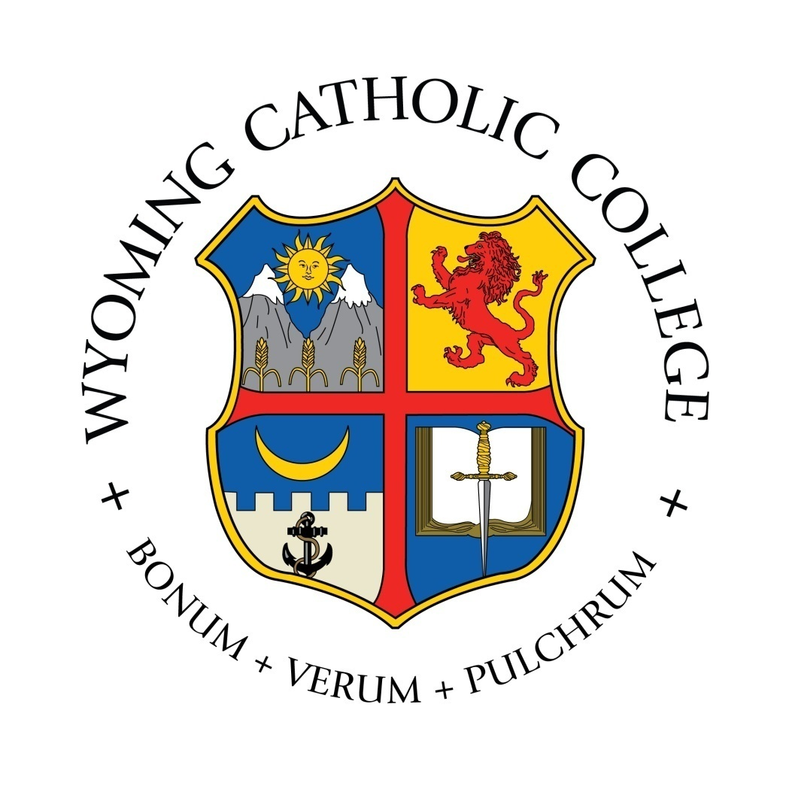

Wyoming Catholic College

Visitor Information

Welcome to Wyoming Catholic College! We hope that you enjoy your time here with us.

Meals - Frassati Hall (275 N 3rd St.)

Breakfast
Monday – Friday: 7:00am—8:30am
Saturday: Continental Breakfast 8:00am—10:00am
Sunday Brunch: 9:30am—11:30am

Lunch
Monday to Saturday: 12:00pm—1:00pm

Dinner
Monday to Saturday: 5:30pm—6:30pm
Sunday: 5:00pm—6:00pm

Chaplaincy – Liturgical events take place either in Holy Rosary Church (HR) or the DeSmet Chapel (DS) in the Baldwin Building.

Holy Mass

Sunday: 8:00am (Extraordinary Form - EF) at Holy Rosary; 7:00pm (Ordinary Form - OF)
Monday, Wednesday: 11:30am at HR (EF)
Tuesday, Friday: 11:30am at HR (OF)
Thursday: 11:30am at HR (OF – All-School Mass)
Saturday: 8:00am at HR (OF, except 1st Saturdays EF); 11:00am at HR on 2nd Saturdays (Byzantine)

Confessions
Monday, Wednesday – Friday: 4:00pm—5:00pm (DS)

Eucharistic Adoration

Monday – Friday: 1:00—5:00pm (DS)

Rosary and Compline (Student-led in HR)

Monday - Friday: 8:10pm

Curfew
Sunday through Thursday: 10:30 pm
Friday and Saturday: Midnight

Visitors are asked to be in the dorms or have left campus (if staying off campus) by curfew. Curfew may be extended for special events.

Quiet Hours (outside dormitory rooms)
Sunday – Thursday: 9:00 pm – 6:00 am

Dress Code - While visitors need not be in dress code, many feel more comfortable to be so and it can add to their experience of the WCC community.

Classroom Dress – the normative dress for class, Mass, and meals

Men: collared shirt tucked in, neat slacks or dark dress jeans with belt, and non-sports shoes or Cowboy boots

Women: dress, skirt, slacks, or blouse with dark dress jeans, and non-sports shoes or Cowboy boots

Formal Dress – liturgies on Sundays and Holy Days, Sunday Brunch, and special events

Men: jacket and tie, dress slacks

Women: dress, a skirt or slacks with blouse

Casual Dress – at all other times, neat and modest in accord with Christian dignity

Contact Information

Assistant Director of Student Life – Mr. Jonathan Rensch, (603)440-4615

Emergency Contact – Mrs. Hillary Halsmer, (209) 617-9114

Questions? - Feel free to ask students any questions you have. They are very friendly and willing to help!

