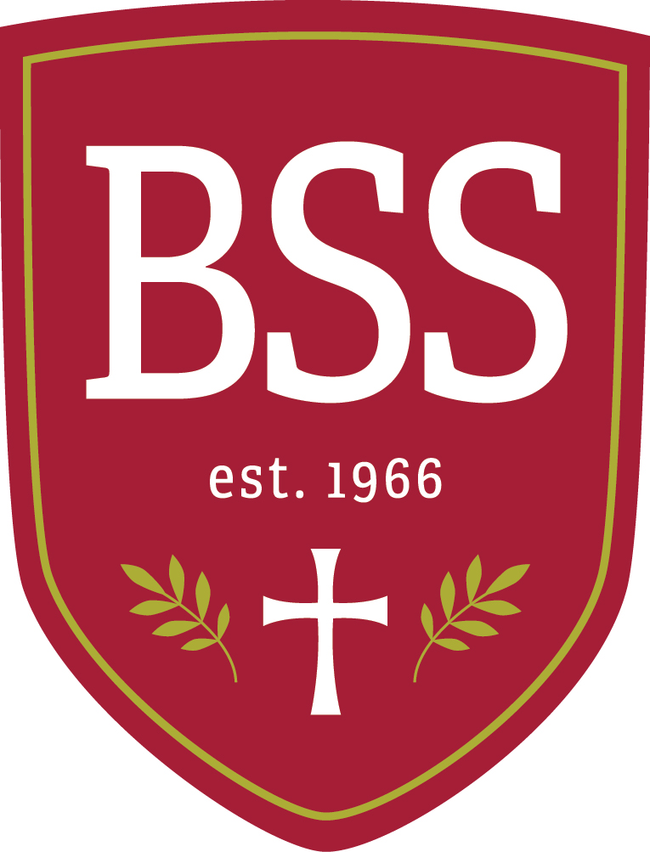

Blessed Sacrament School in Walpole, MA is currently seeking an Assistant Principal, commencing January, 2022 for the remainder of the school year with a school option to hire for the 2022-2023 school year. The assistant principal will be responsible for ensuring that instruction at BSS is meeting the needs of all learners, coordinating special education services, and implementing a program to meet the social/emotional needs of all learners. They will also be assisting the principal in ensuring that the Mission of Blessed Sacrament School is being implemented.
Established in 1966, Blessed Sacrament School provides a Catholic education to children in Pre-Kindergarten through Grade Eight. Blessed Sacrament School strives to nurture every child spiritually, intellectually, socially, physically, and emotionally in an atmosphere of Christian concern. At Blessed Sacrament School, we strive to create great learners and great people who can be the hands and feet of Christ in our world.
Candidates for this position should meet the following qualifications:
- A degree of Master of Education or higher
- A commitment to Catholic education
- Prior experience in teaching and school administration (preferred)

Responsibilities Include:

- Work to implement the mission of Blessed Sacrament School and Strategic Plan
- Work with the principal to implement NEASC recommendations
- Monitor curriculum implementation
- Monitor review of resources to support the curriculum
- Inventory and order consumable supplies for classrooms
- Consult on IEP and School Success Plan implementation
- Work with parents and teachers to meet the social/emotional needs of students
- Supervise and evaluate teachers using Archdiocesan T-eval program
- Work to plan new teacher induction and growth program
- Coordinate MAP testing and analysis of data
- Work with the principal to coordinate professional development opportunities for teachers
- Work with Walpole Public Schools to coordinate spending of federal grant funds
- Attend grade level meetings
- Assist with admissions (specific to students with IEPs or 504 plans)
- Attend School Board Meetings and report on school affairs
- Attend Parent Collaborative meetings
- Assist the Principal in the daily running of the school
- Coordinate internal coverage for teaching staff when needed
- Coordinate area high schools visiting BSS and assist with the admissions process for eighth grade students

Submission Instructions: Please submit cover letter, resume and any other pertinent information to

Dr. Bob Gonet
Director of Leadership
Roman Catholic Archdiocese of Boston
Catholic Schools Office
66 Brooks Drive
Braintree MA 02184
Robert_Gonet@rcab.org | 781-454-9300

